Online Stockiest Management System
Spares Module

For

Document: STOCKIST MANAGEMENT SRS V0

Release Date:



Revision History
Version | Date of Revision | Prepared / Updated By | Reviewed By | Reason for Change | Affected Sections
1.0 |  | Shailendra Kumar | Shailendra Kumar

Approvals
Toshiba Business Team | Toshiba IT Team

Table of Contents

INTRODUCTION 5
1.1 Executive Summary 5
1.2 Scope 5
1.3 Process Flow of Complete Process 5
1.3.1 Deployment & Customization of Spares Module of Hi-Tech’s Online Dealer Management System containing following Modules / functionalities for TMIC Stockiest: 5
1.3.2 Customer Visit Entry by Stockiest 7
1.3.3 Performa/Quotation Creation 8
1.3.4 PI/Quotation Print Format: 11
1.3.5 Revised PI 11
1.3.6 Quotation 12
1.3.7 Annexure for Quotation 12
1.3.8 PI/Quotation Revised Print Format: 12
1.3.9 Purchase Order Creation to OEM (TMIC) 13
1.3.10 Purchase Order Print to OEM (TMIC) 14
1.3.11 Invoice / Dispatch Details Uploaded by OEM (TMIC) 15
1.3.12 GRN Creation by Stockiest 16
1.3.13 Delivery Challan print for WARRANTY PART 17
1.3.14 DC Print FOR REJECTED PART 18
1.3.15 Customer Sales Order Creation by Stockiest 18
1.3.16 Invoice for customer entry 20
1.3.17 Invoice Print 21
2. User Management 22
3. Stockiest Master 22
4. Country Master 23
5. State Master 23
6. City/Location Master 24
7. Region Master 24
8. Region Vs State Master 24
9. Service Engineer Master 24
10. Sales Engineer Master 25
11. Customer Master 26
12. Customer Group Mapping Master 27
13. Part Master 27
14. Part Price Master 28
15. Model Master 28
16. Part Model Matrix Master 29
17. Part Where Used Matrix Master 29
18. Machine Master 29
19. Machine Parts Master 30
20. Machine History View 32
21. Functionality to upload Excel Data and download the desire Output 32

INTRODUCTION

Executive Summary
STOCKIEST MANAGEMENT is a Stockiest centric, centralized application. Stockiest, Customer related activities corresponding to TMIC and agreed as per contract will be implemented in STOCKIEST MANAGEMENT.
STOCKIEST MANAGEMENT will be used by the Stockiest community across the India.

Scope
The document captures the detail of Stockiest Management – Spare Module that need to be followed at TMIC Stockiest and TMIC Sales and HO Team. This will help the Stockiest to Create Spare Module and view. This document contains over all business process of Stockiest Management which will help Stockiest to document all the transaction in STOCKIEST MANAGEMENT application. Also Stockiest will be able to keep track of the Spare details and its status with TMIC.

Process Flow of Complete Process

Deployment & Customization of Spares Module of Hi-Tech’s Online Dealer Management System containing following Modules / functionalities for TMIC Stockiest:
ONLINE STOCKIST MANAGEMENT SYSTEM - TRANSACTIONS / FUNCTIONALITIES
MODULE | SUB - MODULE | FUNCTIONALITIES / TRANSACTIONS
FULFILL CUSTOMER DEMAND | CUSTOMER VISIT | SEARCH CUSTOMER
FULFILL CUSTOMER DEMAND | CUSTOMER VISIT | CREATE CUSTOMER VISIT
FULFILL CUSTOMER DEMAND | CUSTOMER VISIT | VIEW CUSTOMER VISIT
FULFILL CUSTOMER DEMAND | PROFORMA / QUOTATION | CREATE PROFORMA INVOICE / QUOTATION
FULFILL CUSTOMER DEMAND | PROFORMA / QUOTATION | SEARCH PARTY / CUSTOMER MASTER
FULFILL CUSTOMER DEMAND | PROFORMA / QUOTATION | SEARCH PART SCREEN
FULFILL CUSTOMER DEMAND | PROFORMA / QUOTATION | EXCEL UPLOAD SCREEN
FULFILL CUSTOMER DEMAND | PROFORMA / QUOTATION | PROFORMA / QUOTATION SEARCH SCREEN
FULFILL CUSTOMER DEMAND | PROFORMA / QUOTATION | PROFORMA / QUOTATION VIEW SCREEN
FULFILL CUSTOMER DEMAND | CUSTOMER SALE ORDER | SEARCH CUSTOMER
FULFILL CUSTOMER DEMAND | CUSTOMER SALE ORDER | SEARCH CUSTOMER ORDER
FULFILL CUSTOMER DEMAND | CUSTOMER SALE ORDER | VIEW CUSTOMER ORDER
FULFILL CUSTOMER DEMAND | CUSTOMER SALE ORDER | SEARCH PART
FULFILL CUSTOMER DEMAND | CUSTOMER SALE ORDER | SEARCH PARTY/VENDOR
FULFILL CUSTOMER DEMAND | CUSTOMER INVOICE / COUNTER SALE | COUNTER SALE CREATION SCREEN
FULFILL CUSTOMER DEMAND | CUSTOMER INVOICE / COUNTER SALE | SEARCH PARTY/CUSTOMER SCREEN
FULFILL CUSTOMER DEMAND | CUSTOMER INVOICE / COUNTER SALE | SEARCH PART SCREEN
FULFILL CUSTOMER DEMAND | CUSTOMER INVOICE / COUNTER SALE | SEARCH COUNTER SALE INVOICE
FULFILL CUSTOMER DEMAND | CUSTOMER INVOICE / COUNTER SALE | VIEW COUNTER SALE INVOICE
FULFILL CUSTOMER DEMAND | COUNTER SALE RETURN | CREATE COUNTER SALE RETURN
FULFILL CUSTOMER DEMAND | COUNTER SALE RETURN | SEARCH COUNTER SALE RETURN
FULFILL CUSTOMER DEMAND | COUNTER SALE RETURN | VIEW COUNTER SALE RETURN
PART ORDERING | PURCHASE ORDER CREATION | NEW PO CREATION
PART ORDERING | PURCHASE ORDER CREATION | SEARCH PO SCREEN
PART ORDERING | PURCHASE ORDER CREATION | VIEW PO DETAILS & STATUS
PART ORDERING | PURCHASE ORDER CREATION | IMPORT PART LIST THROUGH CART
PART ORDERING | PURCHASE ORDER CREATION | IMPORT PART LIST THROUGH EXCEL
PART ORDERING | PURCHASE ORDER CREATION | PART SEARCH SCREEN
PART ORDERING | PURCHASE ORDER CREATION | DOWNLOAD PO BY TMIC ADMIN
ACCOUNTS | PAYTMENT & RECEIPTS | ADD PAYMENT DETAILS
ACCOUNTS | PAYTMENT & RECEIPTS | ADD RECEIPT DETAILS
ACCOUNTS | PAYTMENT & RECEIPTS | VIEW PAYMENT DETAILS
ACCOUNTS | PAYTMENT & RECEIPTS | VIEW RECEIPT DETAILS
RECIEVE PARTS | GRN | UPLOAD JDE INVOICE (BY TMIC ADMIN)
RECIEVE PARTS | GRN | GRN SCREEN. ( OEM & LOCAL GRN)
RECIEVE PARTS | GRN | VIEW GRN
RECIEVE PARTS | GRN | SEARCH GRN
RECIEVE PARTS | GRN | VIEW PENDING INVOICE / JDE INVOICE
RECIEVE PARTS | GRN | SEARCH BIN LOCATION
RECIEVE PARTS | GRN | SEARCH PARTY
LOCAL GRN RETURN | LOCAL GRN RETURN  (it’s same as GRN)  GRN will be two categories 1. Toshiba and 2. Stockiest | LOCAL GRN RETURN SCREEN
LOCAL GRN RETURN |  | GRN NUMBER SEARCH SCREEN
LOCAL GRN RETURN |  | LOCAL GRN VIEW SCREEN
LOCAL GRN RETURN |  | SEARCH PART SCREEN
MASTERS | PART MASTER | PART CREATION MASTER
MASTERS | PART MASTER | VIEW PART MASTER
MASTERS | PART MASTER | SEARCH PART
MASTERS | PRICE MASTER | UPLOAD PART PRICE
MASTERS | PRICE MASTER | VIEW PART PRICE
MASTERS | PRICE MASTER | SEARCH PART PRICE
MASTERS | PART BRANCH MASTER | UPDATE BRANCH PART MASTER
MASTERS | PART BRANCH MASTER | SEARCH BRANCH PART MASTER
MASTERS | PART BRANCH MASTER | VIEW BRANCH PART MASTER
MASTERS | CUSTOMER MASTER | SYNC CUSTOMER FROM SCMS / OTHER APPLICATION
MASTERS | CUSTOMER MASTER | SYNC CUSTOMER Vs MACHINE FROM SCMS / OTHER APPLICATION
MASTERS | CUSTOMER MASTER | VIEW CUSTOMER
MASTERS | CUSTOMER MASTER | MODIFY CUSTOMER
MASTERS | STORE MASTER | STORE CREATION MASTER
MASTERS | STORE MASTER | SEARCH STORE PART MASTER
MASTERS | STORE MASTER | VIEW STORE PART MASTER
MASTERS | PART CATEGORY | SEARCH PART CATEOGRY
MASTERS | PART CATEGORY | VIEW PART CATEGORY
USER MGMT | USER MGMT | ADD / MODIFY DELETE DEALER / DISTRIBUTOR
USER MGMT | USER MGMT | CREATE USER HIERARCHY
USER MGMT | USER MGMT | ADD / MODIFY DELETE USER
USER MGMT | USER MGMT | CREATE / MODIFY ROLES
USER MGMT | USER MGMT | ASSIGN ROLES TO USER
USER MGMT | USER MGMT | CHANGE PASSWORD
USER MGMT | USER MGMT | VIEW OWN PROFILE
REPORTS | REPORTS | DETAILS OF OFFERS GIVEN TO ALL CUSTOMER FOR A PERIOD
REPORTS | REPORTS | DETAILS OF ORDERS RECEIVED FROM CUSTOMERS FOR A PERIOD
REPORTS | REPORTS | DETAILS OF PURCHASE ORDERS SENT TO TMIC FOR A PERIOD
REPORTS | REPORTS | SALES DETAILS FOR A PERIOD
REPORTS | REPORTS | STOCKS DETAILS
REPORTS | REPORTS | MOVEMENT OF INDIVIDUAL PARTS
REPORTS | REPORTS | AVERAGE DISCOUNT GIVEN TO CUSTOMERS (CUSTOMER WISE)
REPORTS | REPORTS | AVERAGE CREDIT PERIOD TAKEN BY CUSTOMER
REPORTS | REPORTS | PART NUMBER WISE QUERY AND ITS STOCK DETAILS
REPORTS | REPORTS | PART NUMBER WISE SALES TO CUSTOMER FOR A PERIOD
REPORTS | REPORTS | SERIAL NUMBER WISE PURCHASES /SALES
REPORTS | REPORTS | DETAILS OF CUSTOMER’S VISIT
REPORTS | REPORTS | MONTH WISE SALES DETAILS
REPORTS | REPORTS | GROUP CODE WISE INVOICE DETAILS
REPORTS | REPORTS | CUSTOMER CODE WISE INVOICE DETAILS
REPORTS | REPORTS | DISPATCH DETAILS
REPORTS | REPORTS | DETAILS OF PARTS QUOTED IN ALL QUOTATIONS/ PROFORMA INVOICES
REPORTS | REPORTS | SALES DETAILS TO GST AUTHORITIES
REPORTS | REPORTS | PURCHASE DETAILS TO GST AUTHORITIES
REPORTS | REPORTS | DETAILS OF OFFERS GIVEN WITH STATUS FOR A PERIOD
REPORTS | REPORTS | DETAILS OF QUERIES RECEIVED AND ITS STATUS FOR A PERIOD
TICKET MGMT | TICKET MGMT | CREATE TICKET
TICKET MGMT | TICKET MGMT | SEARCH TICKET
TICKET MGMT | TICKET MGMT | VIEW TICKET
TICKET MGMT | TICKET MGMT | ASSIGN TICKET BY TMIC ADMIN
TICKET MGMT | TICKET MGMT | CLOSE TICKET WITH REMARKS BY ASSIGNEE

Customer Visit Entry by Stockiest
Customer Visit functionalities are related to customer enquiry
- Mail functionalities will be available
- View option will be available along with enquiry list
- Enquiry number will be generated

Customer Visit Entry by Stockiest
S. No. | Field Information | Field Type | Is Mandatory | Remarks
1 | Customer Visit Number (System generated) | Display | - | €
2 | Customer Code | LOV - Selection | Yes
3 | Customer Group Code | Display | -
4 | Customer Name | Display | - | €
5 | Customer Address | Display | -
6 | Contact Person Name (2 Field) (changeable) | Display + Entry | Yes
7 | Contact person E-Mail (2 Field) (changeable) | Display + Entry | Yes
8 | Contact Number (2 Field) (changeable) | Display + Entry | Yes
9 | Customer GSTIN Number | Display | -
10 | Location | Display | -
11 | Region | Display | -
12 | State | Display | -
13 | Country | Display | -
14 | Customer Visit Category (From master List) | LOV - Selection | Yes
15 | Machine Serial Number (Not mandatory) | LOV - Selection | No
16 | Cusomer Voice (Issue / complaint / remark) | Entry | Yes
17 | Action Taken | Entry | Yes
18 | Last Visit date | Display | -
19 | Remarks/other requirement-1/Other Points1 | Entry | Yes
20 | Type Domestic/Export | Display | -
21 | Type Domestic/SEZ/EOU/GST EXEMPTION | Display | -
22 | LEAD TYPE - (Stockiest/Service Engg/Sales Engg/Factory Person) | LOV - Selection | Yes
23 | Lead person name | Entry | Yes
24 | Stockiest Name | Display | -
25 | Stockiest Code (from Login) | Display | -

Performa/Quotation Creation
- Performa/Quotation will be based on Customer Visit or Individual (without Customer Visit details)
- Revision will be available against PI/Quotation, revision number will be created
- Offline PI/Quotation will be created
- Print Will be generated as per given format
- Mail functionalities will be available
- View option will be available along with PI/Quotation list

Performa Invoice Creation
S. No. | Field Information | Field Type | Is Mandatory | Remarks
1 | Performa / Quotation | LOV – Selection | Yes
2 | Party Type (drop menu) | LOV – Selection | Yes
3 | Customer Visit Number | Display | -
4 | Customer Name | Display | -
5 | Customer Code | LOV – Selection | Yes
6 | Customer Address | Display | -
7 | Contact Person Name (2 Field) (changeable) | Display + Entry | Yes
8 | Contact person E-Mail (2 Field) (changeable) | Display + Entry | Yes
9 | Contact Number (2 Field) (changeable) | Display + Entry | Yes
10 | Customer GSTIN Number | Display | -
11 | Location | Display | -
12 | Region | Display | -
13 | State | Display | -
14 | Country | Display | -
15 | Part Number | LOV – Selection | Yes
16 | Part Description | Display | -
17 | Quantity | Entry | Yes
18 | UOM | Display | -
19 | Tarif Number/HSN Code | Display | -
20 | Unit Price | Display | -
21 | Total Price | Display | -
22 | Conversion factor | Entry | Yes
23 | Unit price after Conversion | Display | -
24 | Total Converted Price | Display | -
25 | Machine Serial Number (Not mandatory) | LOV - Selection | No
26 | Current Status (Drop menu List) | LOV - Selection | Yes
27 | Last Visit date | Display | -
28 | Remarks/other requirement-1/Other Points1 | Entry | Yes
29 | Mail to Spares Team | Sent Mail to Team | -
30 | Type Domestic/Export | Display | -
31 | Type Domestic/SEZ/EOU/GST EXEMPTION | Display | -
32 | LEAD TYPE - (Stockiest/Service Engg/Sales Engg/Factory Person) | LOV - Selection | Yes
33 | PI Number (System generated) | Display | -
34 | Lead person name | Entry | Yes
35 | PI Date | Display | -
36 | PI Validity (30 / 45 / 60...) | LOV - Selection | Yes
37 | Delivery Terms | Entry | Yes
38 | Packing Charges | Entry | Yes
39 | Freight charges | Entry | Yes
40 | Insurance | Entry | Yes
41 | Payment Terms (drop menu) | LOV - Selection | Yes
42 | Tax Details/IGST/CGST/SGST | Display | -
43 | Net Price | Display | -
44 | Gross Price | Display | -
45 | Gross Price In words | Display | -
46 | Terms & Conditions of Offer (master WRT each Stockist) | Display | -
47 | Bank Details (master WRT each Stockist) | LOV - Selection | Yes
48 | Annexure for PI | Display - Print Format | -
49 | Order Type - Break Down/Stock | LOV - Selection | Yes
50 | Revised PI Number | LOV - Selection | Yes
51 | Revised PI Date | Display | -
52 | Special Instruction | Entry | Yes
53 | Stockiest Name | Display | -
54 | Stockiest Code (from Login) | Display | -
55 | Dispatch Mode (Drop menu By Air/ Road) | LOV - Selection | Yes
56 | Freight Type ( Paid / To pay) | LOV - Selection | Yes
57 | Service Call Number (Not mandatory) | Entry | No
58 | TMIC/STOCKIEST HEADER | Display | -
59 | Customer Group Code | Display | -
60 | Service charge Type ( By TMIC / by Stockist) | LOV - Selection | Yes
61 | Service Charges | Entry | Yes
62 | Customer Order Number | Entry | NO
63 | Customer Order Date | Entry | NO

PI/Quotation Print Format:
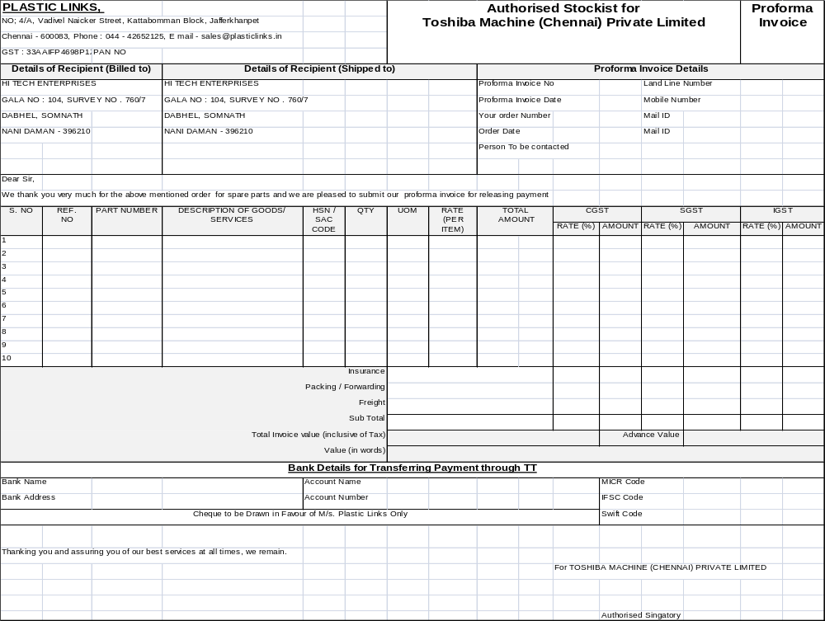

Revised PI
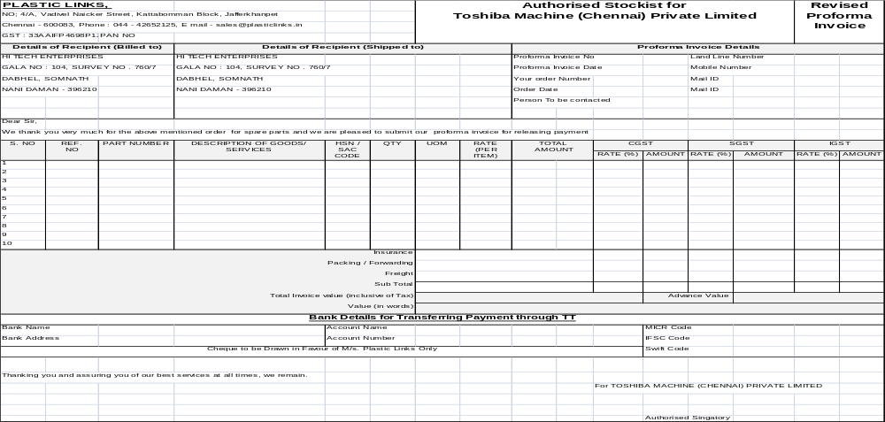

Quotation

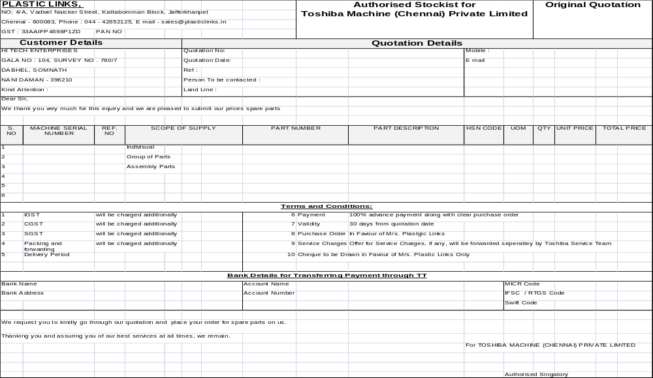

Annexure for Quotation
- In case of Assembly and Group of parts annexure will be filled by stockiest
- in case of assembly parts all the assembly parts will be visible
- in case of group of parts assembly, individual parts

PI/Quotation Revised Print Format:

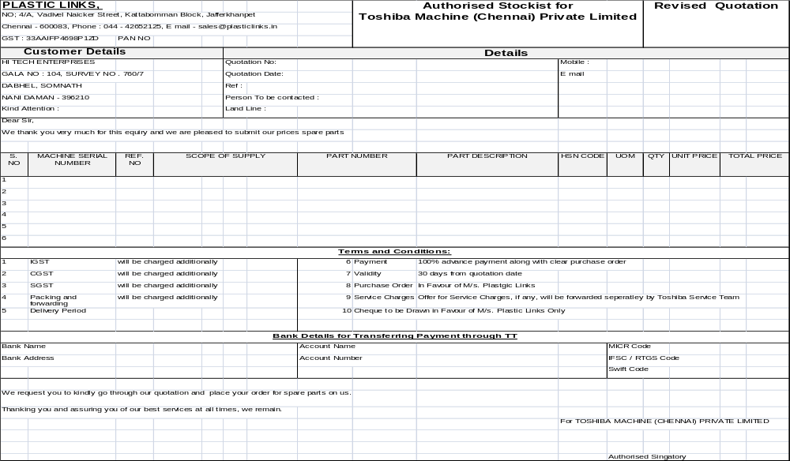

Purchase Order Creation to OEM (TMIC)
- Stockiest will create the PO for OEM
- All the option mentioned below will be available during creation
- All the LOVs will have masters and values will display as per active status
- Mail functionalities will be available
- View option will be available along with order list

Purchase Order Creation to TMIC
S. No. | Field Information | Field Type | Is Mandatory | Remarks
1 | PO Number (System generated) | Display | -
2 | PODate | Display | -
3 | Order Type - Break Down/Stock | LOV - Selection | Yes
4 | Party Type (drop menu) | LOV - Selection | Yes
5 | Party Code (TMIC / Co - Stockist) | LOV - Selection | Yes
6 | party name | LOV - Selection | Yes
7 | Customer Name | Display | -
8 | Customer Code (Not mandatory) | LOV - Selection | Yes
9 | Customer Group Code | Display | -
10 | Location | Display | -
11 | Part Number | LOV - Selection | Yes
12 | Part Description | Display | -
13 | Quantity | Entry | Yes
14 | UOM | Display | -
15 | Tarif Number/HSN Code | Display | -
16 | Unit Price | Display | -
17 | Total Price | Display | -
18 | Machine Serial Number (Not mandatory) | LOV - Selection | No
19 | Special Instruction | Entry | Yes
20 | LEAD TYPE - (Stockiest/Service Engg/Sales Engg/Factory Person) | LOV - Selection | Yes
21 | Lead person name | Entry | Yes
22 | Customer PO / Sale Order No. | LOV - Selection | No
23 | T & C - Price (Drop menu) | LOV - Selection | Yes
24 | T & C - payment terms (Drop menu) | LOV - Selection | Yes
25 | T & C - Freight charges (Drop menu) | LOV - Selection | Yes
26 | T & C - Mode of Dispatch (Drop menu) | LOV - Selection | Yes
27 | Delivery Time | Entry | Yes
28 | Gross Price In words | Display | -
29 | Stockiest Name | Display | -
30 | Stockiest Code (from Login) | Display | -
31 | Dispatch Mode (Drop menu By Air/ Road) | LOV - Selection | Yes

Purchase Order Print to OEM (TMIC)
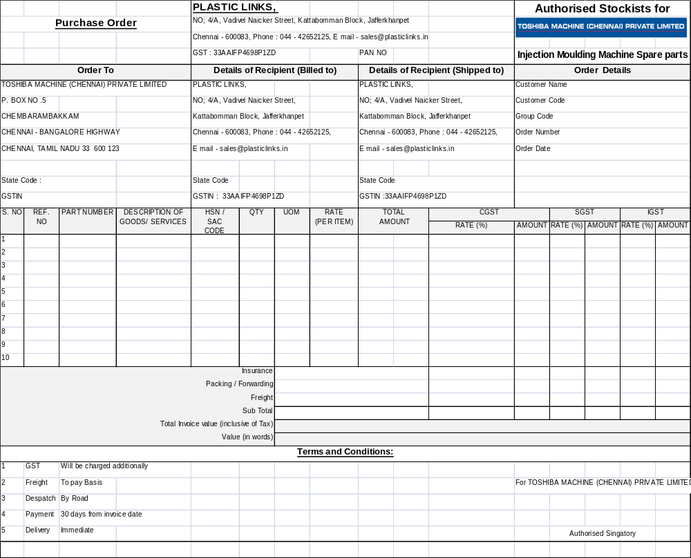

Invoice / Dispatch Details Uploaded by OEM (TMIC)
- Option will be available to upload the invoice details through excel or entry page provided below
- All the column will be same in excel during updating
- Mail functionalities will be available
- View option will be available along with Invoice list

Invoice / Dispatch Detail Upload by TMIC
FS. No. | Field Information | Field Type | Is Mandatory | Remarks
1 | Stockiest Code | Entry | Yes
2 | Stockiest Name | Entry | Yes
3 | Stockiest Order Number | Entry | Yes
4 | Stockiest Order Date | Entry | Yes
5 | Stockiest Ordered Quantity | Entry | Yes
6 | Customer PO Ref No. | Entry | No
7 | Part Number | Entry | Yes
8 | Part Description | Entry | Yes
9 | Quantity | Entry | Yes
10 | UOM | Entry | Yes
11 | Unit Price | Entry | Yes
12 | Remarks/other requirement-1/Other Points1 | Entry | No
13 | Basic Price | Entry | Yes
14 | Packing Charges | Entry | Yes
15 | Freight charges | Entry | Yes
16 | Freight Type - Road/Air | Entry | Yes
17 | Insurance | Entry | Yes
18 | Payment Terms | Entry | Yes
19 | Tax Details/IGST/CGST/SGST | Entry | Yes
20 | Net Price | Entry | Yes
21 | Gross Price | Entry | Yes
22 | Gross Price In words | Entry | Yes
23 | Special Instruction | Entry | No
24 | Packing Type | Entry | Yes
25 | Date of Despatch | Entry | Yes
26 | Category | Entry | Yes
27 | Branch Plant | Entry | Yes
28 | TMIC Invoice Number | Entry | Yes
29 | TMIC Invoice Date | Entry | Yes
30 | BDN Number | Entry | Yes
31 | BDN Date | Entry | Yes
32 | Dispatch Mode (Drop menu By Air/ Road) | Entry | Yes
33 | Courier Name | Entry | Yes
34 | Courier Code | Entry | Yes
35 | Courier Docket Number | Entry | Yes
36 | Docket Date | Entry | Yes

GRN Creation by Stockiest
- Option will be available to generate GRN and manage inventory based on Invoice
- From point no 37 all the details in invoice will be visible during GRN for entry
- Inventory will be updated after GRN
- In case of damage and wrong part supply delivery challan will be create
- Delivery challan format has been given below
- Mail functionalities will be available
- View option will be available along with Invoice list

GRN Creation by Stockist
S. No. | Field Information | Field Type | Is Mandatory | Remarks
1 | TMIC Invoice Number | LOV - Selection | Yes
2 | Invoice date | Display | -
3 | Part number | Display | -
4 | Qty | Display | -
5 | UOM | Display | -
6 | Unit price | Display | -
7 | Total price | Display | -
8 | Part desc | Display | -
9 | GST (IGST/CGST) | Display | -
10 | Packing charge | Entry | Yes
11 | Packing type | Entry | Yes
12 | freight type | Entry | Yes
13 | freight charge | Entry | Yes
14 | Stockist PO number | Display | -
15 | PO date | Display | -
16 | Customer PO number | Display | -
17 | PO date | Display | -
18 | Delivery Mode | Display | -
19 | Courier Name | Display | -
20 | Transport name | Display | -
21 | box number | Entry | Yes | On Header Level
22 | Box Quantity | Entry | Yes
23 | BoX Type- Carton/Wooden/Bundle/Roll | Entry | Yes
24 | Box Size L/W/B | Entry | Yes
25 | Box Weight | Entry | Yes
26 | Charges patten - Volumetric Type/Acctual | Entry | Yes
27 | Volumetric Weight | Entry | Yes
28 | Volumetric Weight Charges | Entry | Yes
29 | Actual Weight | Entry | Yes
30 | Actual Weight Charges | Entry | Yes
31 | Short/faulty part/wrong/excess | Entry | Yes | Only if applicable

Delivery Challan print for WARRANTY PART
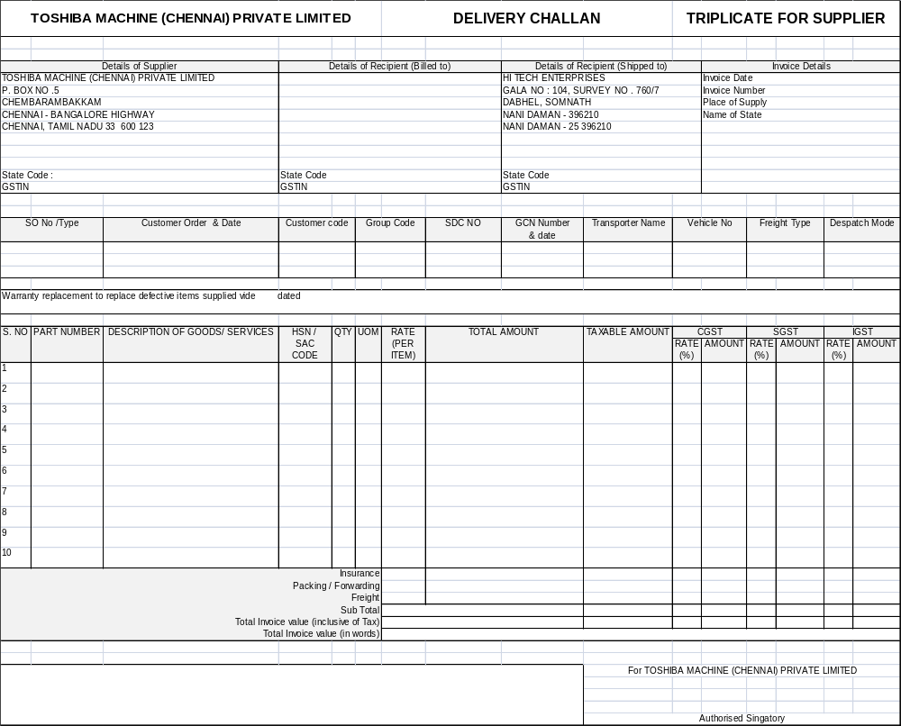

DC Print FOR REJECTED PART
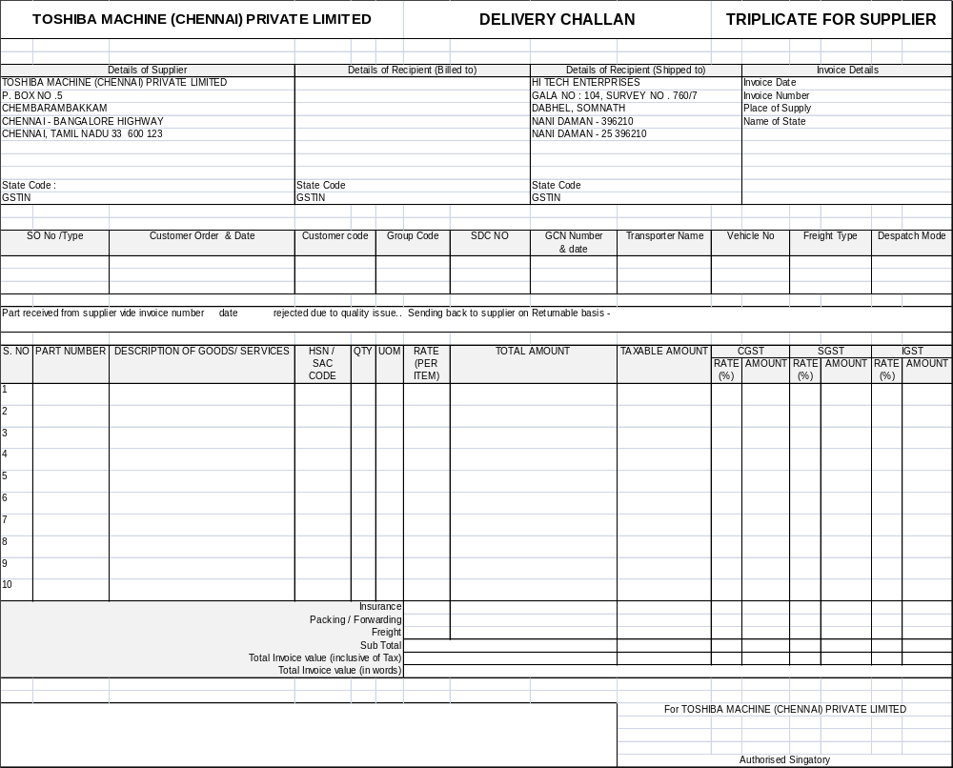

Customer Sales Order Creation by Stockiest
- Stockiest will create the Sales Order on behalf of Customer
- All the entry fields will be same as given below
- All the LoVs will be display from masters
- Stockiest can create the sales order for export user also

Customer Sale Order Entry by Stockiest
S. No. | Field Information | Field Type | Is Mandatory | Remarks
1 | Customer PO No. (System generated) | Display | -
2 | Customer PO Ref NO. | Entry | Yes
3 | Customer PO Date | Entry | Yes
4 | Customer Name | Display | -
5 | Customer Code | LOV - Selection | Yes
6 | Customer Group Code | Display | -
7 | Customer Address | Display | -
8 | Customer GSTIN Number | Display | -
9 | Location | Display | -
10 | Region | Display | -
11 | State | Display | -
12 | Country | Display | -
13 | PI Number (not mandatory) | LOV - Selection | Yes
14 | Part Number (editable.....automatically based on PI if selected) | LOV - Selection | Yes
15 | Part Description | Display | -
16 | Quantity | Entry | Yes
17 | UOM | Display | -
18 | Stock Type (from part master only) | Display | -
19 | Tarif Number/HSN Code | Display | -
20 | Unit Price | Display | -
21 | Total Price | Display | -
22 | Machine Serial Number (Not mandatory) | LOV - Selection | Yes
23 | Remarks/other requirement-1/Other Points1 | Entry | Yes
24 | Mail to Spares Team | Display | -
25 | Type Domestic/Export | Display | -
26 | Type Domestic/SEZ/EOU/GST EXEMPTION | Display | -
27 | LEAD TYPE - (Stockiest/Service Engg/Sales Engg/Factory Person) | LOV - Selection | Yes
28 | Lead person name | Entry | Yes
29 | Delivery Terms | Entry | Yes
30 | Basic Price | Display | -
31 | Packing Charges | Entry | Yes
32 | Freight charges | Entry | Yes
33 | Freight Type - ( Paid / To pay) | LOV - Selection | Yes
34 | Insurance | Entry | Yes
35 | Payment Terms (drop menu) | LOV - Selection | Yes
36 | Lead Time mentioned in the Price list WRt part | Display | -
37 | Tax Details/IGST/CGST/SGST | Display | -
38 | Net Price | Display | -
39 | Gross Price | Display | -
40 | Gross Price In words | Display | -
41 | Terms & Conditions of Offer (master WRT each Stockist) | LOV - Selection | Yes
42 | Annexure for PI | YES | YES
43 | Order Type - Break Down/Stock | LOV - Selection | Yes
44 | Special Instruction | Entry | Yes
45 | Stockiest Name | Display | -
46 | Stockiest Code (from Login) | Display | -
47 | Stockiest Order Number | Display | -
48 | Packing Type (carton / Wooden) | LOV - Selection | Yes
49 | Advance Received from customer | Entry | Yes
50 | Standard Credit Period | Entry | Yes
51 | Payment Details | Entry | Yes
52 | Dispatch Mode (Drop menu By Air/ Road) | LOV - Selection | Yes

Invoice for customer entry
- Stockiest will create the Invoice against Sales Order for Customer
- All the entry fields will be same as given below
- All the Lovs will be display from masters
- Invoice number will be generated by system
- Stockiest can create the Invoice for export customer also

Invoice Details to Customer by Stockist
S. No. | Field Information | Field Type | Is Mandatory | Remarks
1 | Invoice To (customer name ) | Display | -
2 | bill to | Display | -
3 | ship to | Display | -
4 | Invoice no | Display | -
5 | invoice date | Display | -
6 | Customer order no | LOV - Selection | Yes
7 | Customer order date | Display | -
8 | Part number | Display | -
9 | Part qty | Display | -
10 | Part desc | Display | -
11 | UOM | Display | -
12 | Unit Price | Display | -
13 | total price | Display | -
14 | GST Number (customer) | Display | -
15 | Customer state code | Display | -
16 | Stockist GST number | Display | -
17 | Customer pan number | Display | -
18 | Stockist pan number | Display | -
19 | Tax details (igst/cgst) | Display | -
20 | packing charge | Entry | Yes
21 | freight charge | Entry | Yes
22 | Advance amount | Entry | Yes
23 | payment terms | Display | -
24 | expected payment date | Display | -
25 | actual payment date | Entry | Yes
26 | customer group code | Display | -
27 | transport mode (drop down) | LOV - Selection | Yes
28 | transport cost | Entry | Yes
29 | Material receipt date | Entry | No | Stockist will update it later after the material is received by Customer
30 | Installed by (customer/service engineer / stockist engineer /factor people) | Entry | No | Stockist will update it later after the material is received by Customer
31 | Installation date | Entry | No | Stockist will Update it later after the material is received by Customer

Invoice Print
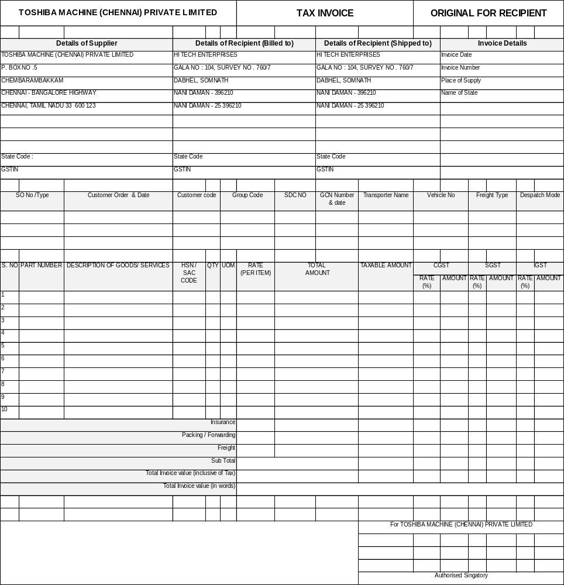

User Management

- User will be different type like HO, Stockiest, Sales Engineer, Service Engineer etc.
- All the users and customer will be associated with region
- User’s transaction matrix has been given below
- Users will be managed through masters

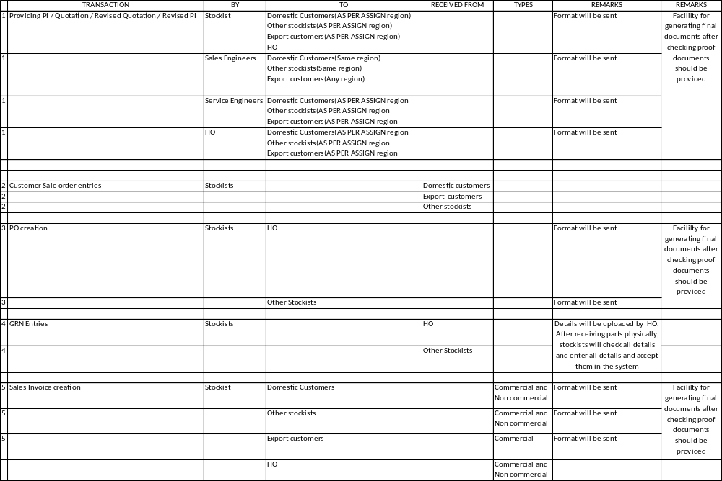

Stockiest Master
- All the created list will be display
- Option will be available for new stockiest entry
- Edit option will be available
- Delete/block option will be available

Stockiest Master
S. No. | Field Information | Field Type | Is Mandatory
1 | Stockist NAME | Entry | Yes
2 | Stockist Code(JDE Code) → | Entry | Yes
3 | ADDRESS Code | Entry | Yes
4 | Stockist ADDRESS | Entry | Yes
5 | Stockist ADDRESS 1 | Entry | Yes
6 | Stockist ADDRESS 2 | Entry | Yes
7 | Stockist ADDRESS 3 | Entry | Yes
8 | Stockist ADDRESS 4 | Entry | Yes
9 | Stockist CITY | LOV - Selection | Yes
10 | Stockist STATE | LOV - Selection | Yes
11 | Stockist REGION | LOV - Selection | Yes
12 | Stockist COUNTRY | LOV - Selection | Yes
13 | PIN CODE | Entry | Yes
14 | LAND LINE | Entry | Yes
15 | FAX | Entry | Yes
16 | PAN NO | Entry | Yes
17 | ECC NO | Entry | Yes
18 | TIN NO | Entry | Yes
19 | CST | Entry | Yes
20 | DIVISION | Entry | Yes
21 | OUR NEW SERVICE TAX NO | Entry | Yes
22 | PI Code | Entry | Yes
23 | GSTIN Number | Entry | Yes
24 | CONTACT PERSON NAME | Entry | Yes
25 | MOBILE 1 | Entry | Yes
26 | MOBILE 2 | Entry | Yes
27 | COMMUNICATION E-MAIL | Entry | Yes
28 | extra Column 1 | Entry | Yes
29 | extra Column 2 | Entry | Yes
30 | extra Column 3 | Entry | Yes
31 | extra Column 4 | Entry | Yes
32 | extra Column 5 | Entry | Yes

Country Master
- All the created list will be display
- Option will be available for new Country entry
- Edit option will be available
- Delete/block option will be available

Country Master
S. No. | Field Information | Field Type | Is Mandatory
1 | Country Code | Entry | Yes
2 | Country Name | Entry | Yes
3 | Country description | Entry | Yes
4 | Active | Entry | Yes

State Master
- All the created list will be display
- Option will be available for new State entry
- Edit option will be available
- Delete/block option will be available

State Master
S. No. | Field Information | Field Type | Is Mandatory
1 | State Code | Entry | Yes
2 | State Name | Entry | Yes
3 | State description | Entry | Yes
4 | Active | Entry | Yes

City/Location Master (After State, no district master)
- All the created list will be display
- Option will be available for new City entry
- Edit option will be available
- Delete/block option will be available

City Master
S. No. | Field Information | Field Type | Is Mandatory
1 | City Code | Entry | Yes
2 | City Name | Entry | Yes
3 | City description | Entry | Yes
4 | Pin Code | Entry | Yes
5 | State Name | Lov Selection | Yes
6 | Active | Entry | Yes

Region Master
- All the created list will be display
- Option will be available for new Region entry
- Edit option will be available
- Delete/block option will be available

Region Master
S. No. | Field Information | Field Type | Is Mandatory
1 | Region Code | Entry | Yes
2 | Region Name | Entry | Yes
3 | Region description | Entry | Yes
4 | Active | Entry | Yes

Region Vs State Master
- All the created list will be display
- Option will be available for new Mapping entry
- Edit option will be available
- Delete/block option will be available

Region Vs State Master
S. No. | Field Information | Field Type | Is Mandatory
1 | Region Code | Lov Selection | Yes
2 | State Name | Multiple Selection | Yes
3 | Active | Entry | Yes

Service Engineer Master

- All the created list will be display
- Option will be available for new Service Engineer entry
- Edit option will be available
- Delete/block option will be available

Service Engineer Master
S. No. | Field Information | Field Type | Is Mandatory
1 | Employee Code | Entry | Yes
2 | NAME | Entry | Yes
3 | INTIALS | Entry | Yes
4 | Sex | Entry | Yes
5 | ADDRESS | Entry | Yes
6 | ADDRESS 1 | Entry | Yes
7 | ADDRESS 2 | Entry | Yes
8 | ADDRESS 3 | Entry | Yes
9 | ADDRESS 4 | Entry | Yes
10 | Pin Code | Entry | Yes
11 | City | LOV - Selection | Yes
12 | State | LOV - Selection | Yes
13 | Region | LOV - Selection | Yes
14 | Country | LOV - Selection | Yes
15 | Mobile No | Entry | Yes
16 | Mobile No.1 | Entry | Yes
17 | Mobile No.2 | Entry | Yes
18 | Email | Entry | Yes
22 | Extra Column 1 | Entry | Yes
23 | Extra Column 2 | Entry | Yes
24 | Extra Column 3 | Entry | Yes
25 | Extra Column 4 | Entry | Yes

Sales Engineer Master

- All the created list will be display
- Option will be available for new Sales Engineer entry
- Edit option will be available
- Delete/block option will be available

Service Engineer Master
S. No. | Field Information | Field Type | Is Mandatory
1 | Employee Code | Entry | Yes
2 | NAME | Entry | Yes
3 | INTIALS | Entry | Yes
4 | Sex | Entry | Yes
5 | ADDRESS | Entry | Yes
6 | ADDRESS 1 | Entry | Yes
7 | ADDRESS 2 | Entry | Yes
8 | ADDRESS 3 | Entry | Yes
9 | ADDRESS 4 | Entry | Yes
10 | Pin Code | Entry | Yes
11 | City | LOV - Selection | Yes
12 | State | LOV - Selection | Yes
13 | Region | LOV - Selection | Yes
14 | Country | LOV - Selection | Yes
15 | Mobile No | Entry | Yes
16 | Mobile No.1 | Entry | Yes
17 | Mobile No.2 | Entry | Yes
18 | Email | Entry | Yes
22 | Extra Column 1 | Entry | Yes
23 | Extra Column 2 | Entry | Yes
24 | Extra Column 3 | Entry | Yes
25 | Extra Column 4 | Entry | Yes

Customer Master

- All the created list will be display
- Option will be available for new Customer entry
- Edit option will be available
- Delete/block option will be available

Customer Master
S. No. | Field Information | Field Type | Is Mandatory
1 | Customer NAME | Entry | Yes
2 | Customer ADDRESS | Entry | Yes
3 | CUSTOMER CODE | Entry | Yes
4 | Customer Code(JDE) | Entry | Yes
5 | Customer Group Code | Entry | Yes
6 | Customer ADDRESS 1 | Entry | Yes
7 | Customer ADDRESS 2 | Entry | Yes
8 | Customer ADDRESS 3 | Entry | Yes
9 | Customer ADDRESS 4 | Entry | Yes
10 | Customer ADDRESS 5 | Entry | Yes
11 | Customer CITY | LOV - Selection | Yes
12 | Customer STATE | LOV - Selection | Yes
13 | Customer REGION | LOV - Selection | Yes
14 | Customer COUNTRY | LOV - Selection | Yes
15 | PIN CODE | Entry | Yes
16 | LAND LINE | Entry | Yes
17 | FAX | Entry | Yes
18 | PAN NO | Entry | Yes
22 | ECC NO | Entry | Yes
23 | RANGE | Entry | Yes
24 | TIN NO | Entry | Yes
25 | CST | Entry | Yes
26 | DIVISION | Entry | Yes
27 | OUR NEW SERVICE TAX NO | Entry | Yes
28 | PI Code | Entry | Yes
29 | GSTIN Number | Entry | Yes
30 | CONTACT PERSON NAME | Entry | Yes
31 | MOBILE 1 | Entry | Yes
32 | MOBILE 2 | Entry | Yes
33 | COMMUNICATION E-MAIL | Entry | Yes
34 | Extra Column 1 | Entry | Yes
35 | Extra Column 2 | Entry | Yes
36 | Extra Column 3 | Entry | Yes
37 | Extra Column 4 | Entry | Yes
38 | Extra Column 5 | Entry | Yes

Customer Group Mapping Master

- All the created list will be display
- Option will be available for new Customer Group Mapping entry
- Edit option will be available
- Delete/block option will be available

Customer Master
S. No. | Field Information | Field Type | Is Mandatory
1 | CUSTOMER NAME | LOV Selection | Yes
2 | CUSTOMER CODE | LOV Selection | Yes
3 | CUSTOMER (JDE CODE) | Entry | Yes
4 | CUSTOMER GROUP CODE | LOV Selection | Yes
5 | Extra Column 1 | Entry | Yes
6 | Extra Column 2 | Entry | Yes
7 | Extra Column 3 | Entry | Yes
8 | Extra Column 4 | Entry | Yes

Part Master

- All the created list will be display
- Option will be available for new Part entry
- Upload from excel will be available
- Edit option will be available
- Delete/block option will be available
- for all parts DMS reference number needs to be created.
- Some OEM parts does not have part number so we need to put the part number

Part Master
S. No. | Field Information | Field Type | Is Mandatory
1 | REF NO | Entry | Yes
2 | Part Number | Entry | Yes
3 | Description | Entry | Yes
4 | Description 1 | Entry | Yes
5 | Description 2 | Entry | Yes
6 | Alternate Part Number | Entry | Yes
7 | Alternate Part Description | Entry | Yes
8 | Part Type (Individual/Assembly) | Entry | Yes
9 | Stock Type | LOV Selection | Yes
10 | FSN Details | Entry | Yes
11 | UOM | Entry | Yes
12 | Lead Time | Entry | Yes
13 | Part Nearest Shape | Entry | Yes
14 | Length | Entry | Yes
15 | Width | Entry | Yes
16 | Height | Entry | Yes
17 | Diameter | Entry | Yes
18 | Weight | Entry | Yes
19 | Area of usage | Entry | Yes
20 | Scope of Supply | Entry | Yes

Part Price Master

- All the created list will be display
- Option will be available for new Part Price entry
- Edit option will be available
- Delete/block option will be available
- Upload from excel will be available

Part Price Master
S. No. | Field Information | Field Type | Is Mandatory
1 | REF NO | Entry | Yes
2 | Part Number | Entry | Yes
3 | Description | Entry | Yes
4 | Description 1 | Entry | Yes
5 | Description 2 | Entry | Yes
6 | UOM | Entry | Yes
7 | Price | Entry | Yes
8 | Effective From | Entry | Yes
9 | Rev. Number | LOV Selection | Yes
10 | Rev. date | Entry | Yes
11 | Current Type (Obsolete) | Entry | Yes
12 | Stock Type | Entry | Yes
13 | Lead Time | Entry | Yes
14 | Extra Column 1 | Entry | Yes
15 | Extra Column 2 | Entry | Yes
16 | Extra Column 3 | Entry | Yes
17 | Extra Column 4 | Entry | Yes
18 | Extra Column 5 | Entry | Yes

Model Master

- All the created list will be display
- Option will be available for new Model entry
- Edit option will be available
- Delete/block option will be available
- Upload from excel will be available

Customer Master
S. No. | Field Information | Field Type | Is Mandatory
1 | Model Code | Entry | Yes
2 | Model Master | Entry | Yes
3 | Model Description | Entry | Yes
4 | Extra Column 1 | Entry | Yes
5 | Extra Column 2 | Entry | Yes
6 | Extra Column 3 | Entry | Yes
7 | Extra Column 4 | Entry | Yes

Part Model Matrix Master

- All the created list will be display
- Option will be available for new Part Model entry
- Edit option will be available
- Delete/block option will be available
- Upload from excel will be available

Customer Master
S. No. | Field Information | Field Type | Is Mandatory
1 | Model Code | LOV Selection | Yes
2 | Part Number | LOV Selection Multiple Selection | Yes

Part Where Used Matrix Master

- All the created list will be display
- Option will be available for new Part Where Used entry
- Edit option will be available
- Delete/block option will be available
- Upload from excel will be available

Customer Master
S. No. | Field Information | Field Type | Is Mandatory
1 | Part Number | LOV Selection | Yes
2 | Where Used | LOV Selection Multiple Selection | Yes
3 | Reserved | Entry | Yes

Machine Master

- All the created list will be display
- Option will be available for new Machine entry
- Edit option will be available
- Delete/block option will be available
- Upload from excel will be available
- Machine will be uploaded based on Category selection
- Every time machine details will be uploaded and history will be maintained

Machine Master
S. No. | Field Information | Field Type | Is Mandatory
1 | REF | Entry | Yes
2 | MACHINE SERIAL NUMBER | Entry | Yes
3 | CATEGORY | LOV selection | Yes
4 | DESPATCH DATE | Entry | Yes
5 | INVOICE NO | Entry | Yes
6 | WORK ORDER | Entry | Yes
7 | SALE ORDER | Entry | Yes
8 | CUSTOMER NAME | Entry | Yes
9 | CUSTOMER CODE | Entry | Yes
10 | GROUP CODE | Entry | Yes
11 | CUSTOMER LOCATION | Entry | Yes
12 | REGION | Entry | Yes
13 | SERIES | Entry | Yes
14 | CU/TBD | Entry | Yes
15 | IU | Entry | Yes
16 | CONTROLS | Entry | Yes
17 | HYDROMOTOR | Entry | Yes
18 | SCREW SIZE | Entry | Yes
19 | MOTOR UNIT | Entry | Yes
20 | PUMP UNIT | Entry | Yes
21 | SCREW TYPE | Entry | Yes
22 | CYLINDER TYPE | Entry | Yes
23 | Extra Column 1 | Entry | Yes
24 | Extra Column 2 | Entry | Yes
25 | Extra Column 3 | Entry | Yes
26 | Extra Column 4 | Entry | Yes
27 | Extra Column 5 | Entry | Yes
28 | Extra Column 6 | Entry | Yes
29 | Extra Column 7 | Entry | Yes
30 | Extra Column 8 | Entry | Yes
31 | Extra Column 9 | Entry | Yes
32 | Extra Column 10 | Entry | Yes
33 | ATTACH PDF FILE | Upload File Option | Yes

Machine Parts Master

- All the created list will be display
- Option will be available for new Machine Parts entry
- Edit option will be available
- Delete/block option will be available
- Upload from excel will be available
- Every time machine will have parts details and it will be uploaded and history will be maintained

Machine Parts Master
S. No. | Field Information | Field Type | Is Mandatory
2 | REF | Entry | Yes
3 | MACHINE SERIAL NUMBER | Entry | Yes
4 | CATEGORY | Entry | Yes
5 | DESPATCH DATE | Entry | Yes
6 | INVOCIE NUMBER | Entry | Yes
7 | WORK ORDER | Entry | Yes
8 | SALE ORDER | Entry | Yes
9 | PART NUMBER | Entry | Yes
10 | PART DESCRIPTGION | Entry | Yes
11 | QTY | Entry | Yes
12 | SEQUENCE NUMBER | Entry | Yes
13 | UOM | Entry | Yes
14 | UNIT COST | Entry | Yes
15 | TOTAL COST | Entry | Yes
16 | Nearest shape | Entry | Yes
17 | Length | Entry | Yes
18 | Width | Entry | Yes
19 | Height | Entry | Yes
20 | Diameter | Entry | Yes
21 | Weight | Entry | Yes
22 | Extra Column 1 | Entry | Yes
23 | Extra Column 2 | Entry | Yes
24 | Extra Column 3 | Entry | Yes
25 | Extra Column 4 | Entry | Yes
26 | Extra Column 5 | Entry | Yes
27 | Extra Column 6 | Entry | Yes
28 | Extra Column 7 | Entry | Yes
29 | Extra Column 8 | Entry | Yes
30 | Extra Column 9 | Entry | Yes
31 | Extra Column 10 | Entry | Yes
32 | Extra Column 11 | Entry | Yes
33 | Extra Column 12 | Entry | Yes
34 | Extra Column 13 | Entry | Yes

Machine History View

- Machine history will be based on Machine serial Number
- So input will be Machine Sr. No.
- Last updated details of below column will be display on header
- Machine Details will be based on Criteria like Equipment, Warranty Parts, Goodwill, Saleable Parts and ALL
- Machine details will be display as per below format

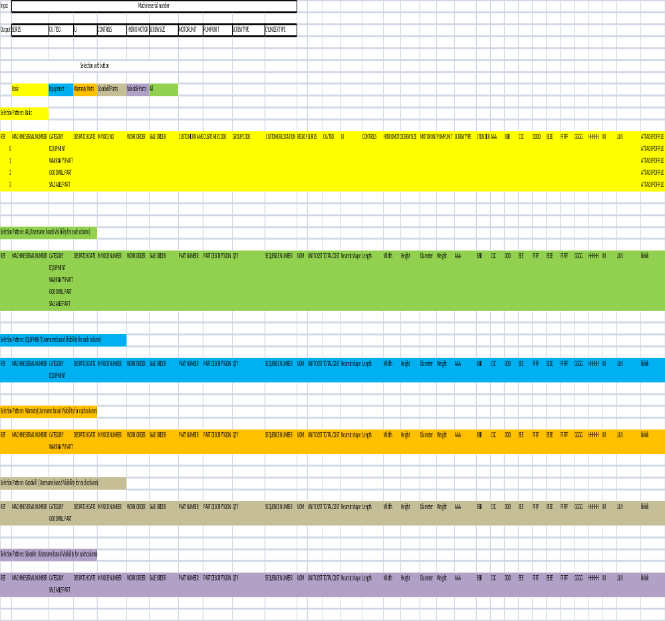

Functionality to upload Excel Data and download the desire Output

- Option will be available to upload the excel data in specific format
- Logic will be implemented as per provided excel
- Final output will be downloaded in excel

